# Question 1

## Question 1.2

**Visualization 1.2.1**

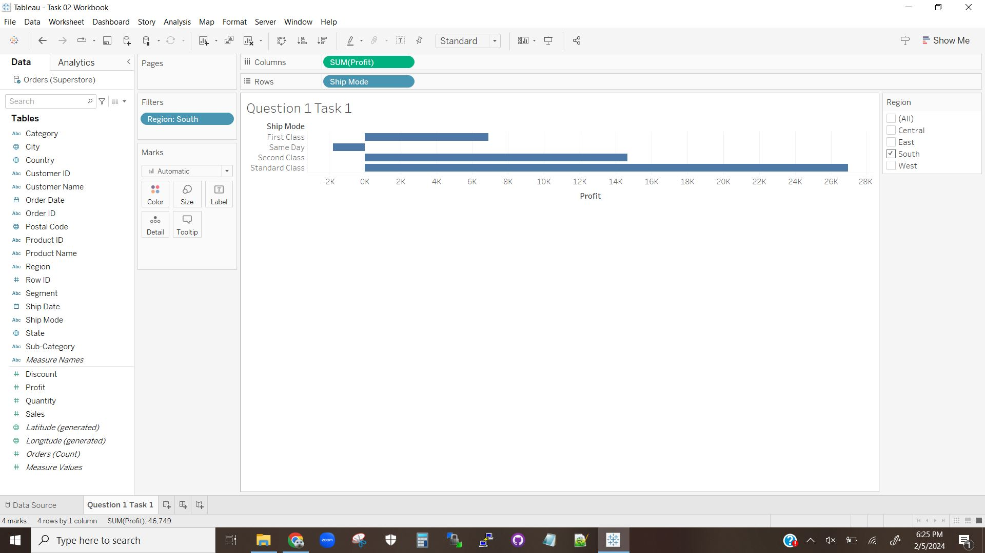

The above Visualization shows that the Standard Class mode is by far the most profitable in the South region, while the Same Day mode actually loses the company money in the South region.

**Visualization 1.2.2**

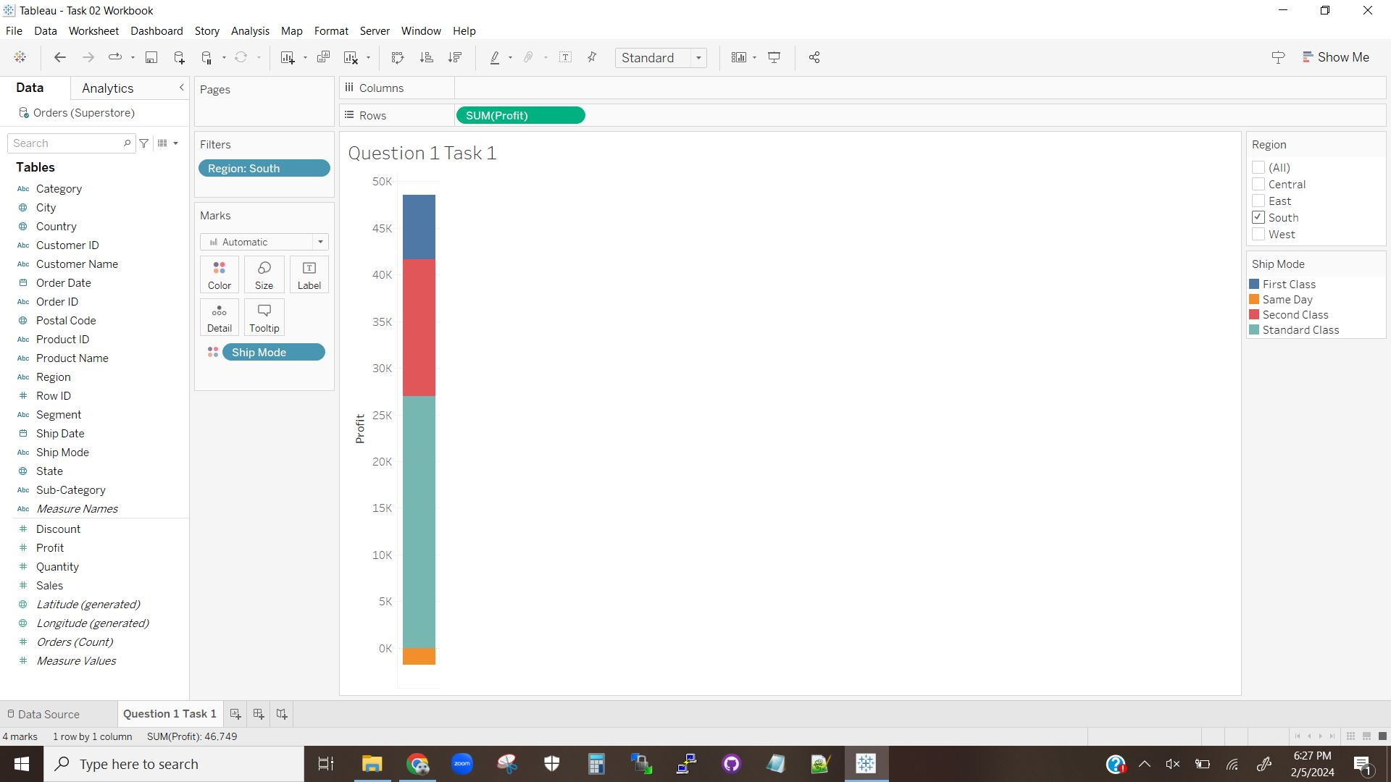

The above Visualization shows that, for the South region, sales are about $48K with Standard Class accounting for nearly half of profits. The Visualization also shows that the loss in profits created by Same Day are very small in proportion to the entire sum.

## Question 1.3

**Visualization 1.3.1**

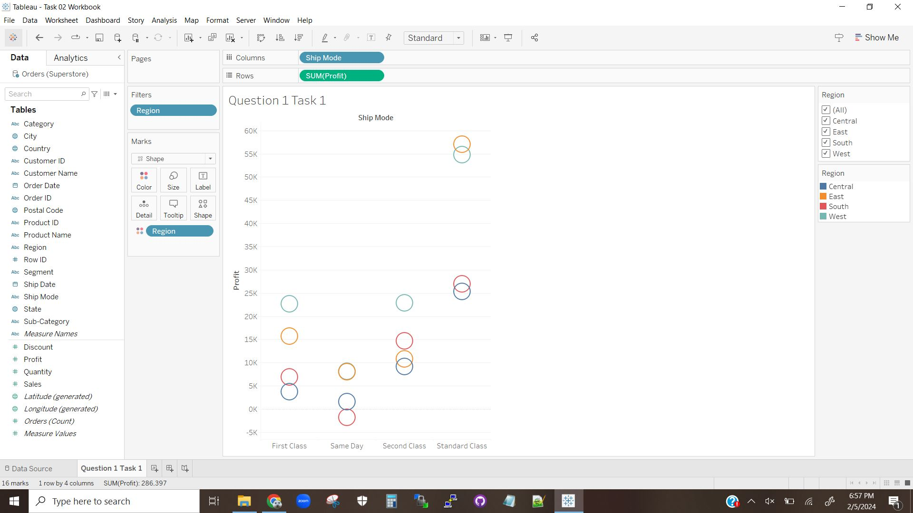

The above Visualization shows the profits for all regions, with the individual regions separated into color categories and displayed such that values between the regions are directly comparable.

The West region of Ship Mode has the the most profit at $22,638. The next most profitable region is the East region, at $17532 making a $5,106 difference.

## Question 1.4

According to Visualization 1.2.1, the Same Day mode has the lowest profits in the South region.

According to Visualization 1.3.1, all of the other regions in the Same Day mode have lower profits than in the other modes, though all are positive and the top two regions (East and West) are competitive with the lowest profiting regions in the other Shipping Modes. Overall though, the Same Day mode tends to perform poorly.

## Question 1.5 (Explanation)

The purpose of this question was to demonstrate how to generate multiple views of the same data to produce different information. Additionally this task pushes users to use different visualizations to generate different pieces of information that can be combined to form answers to questions or form conclusions.

# Question 2

## Question 2.1

**Visualization 2.1.1**

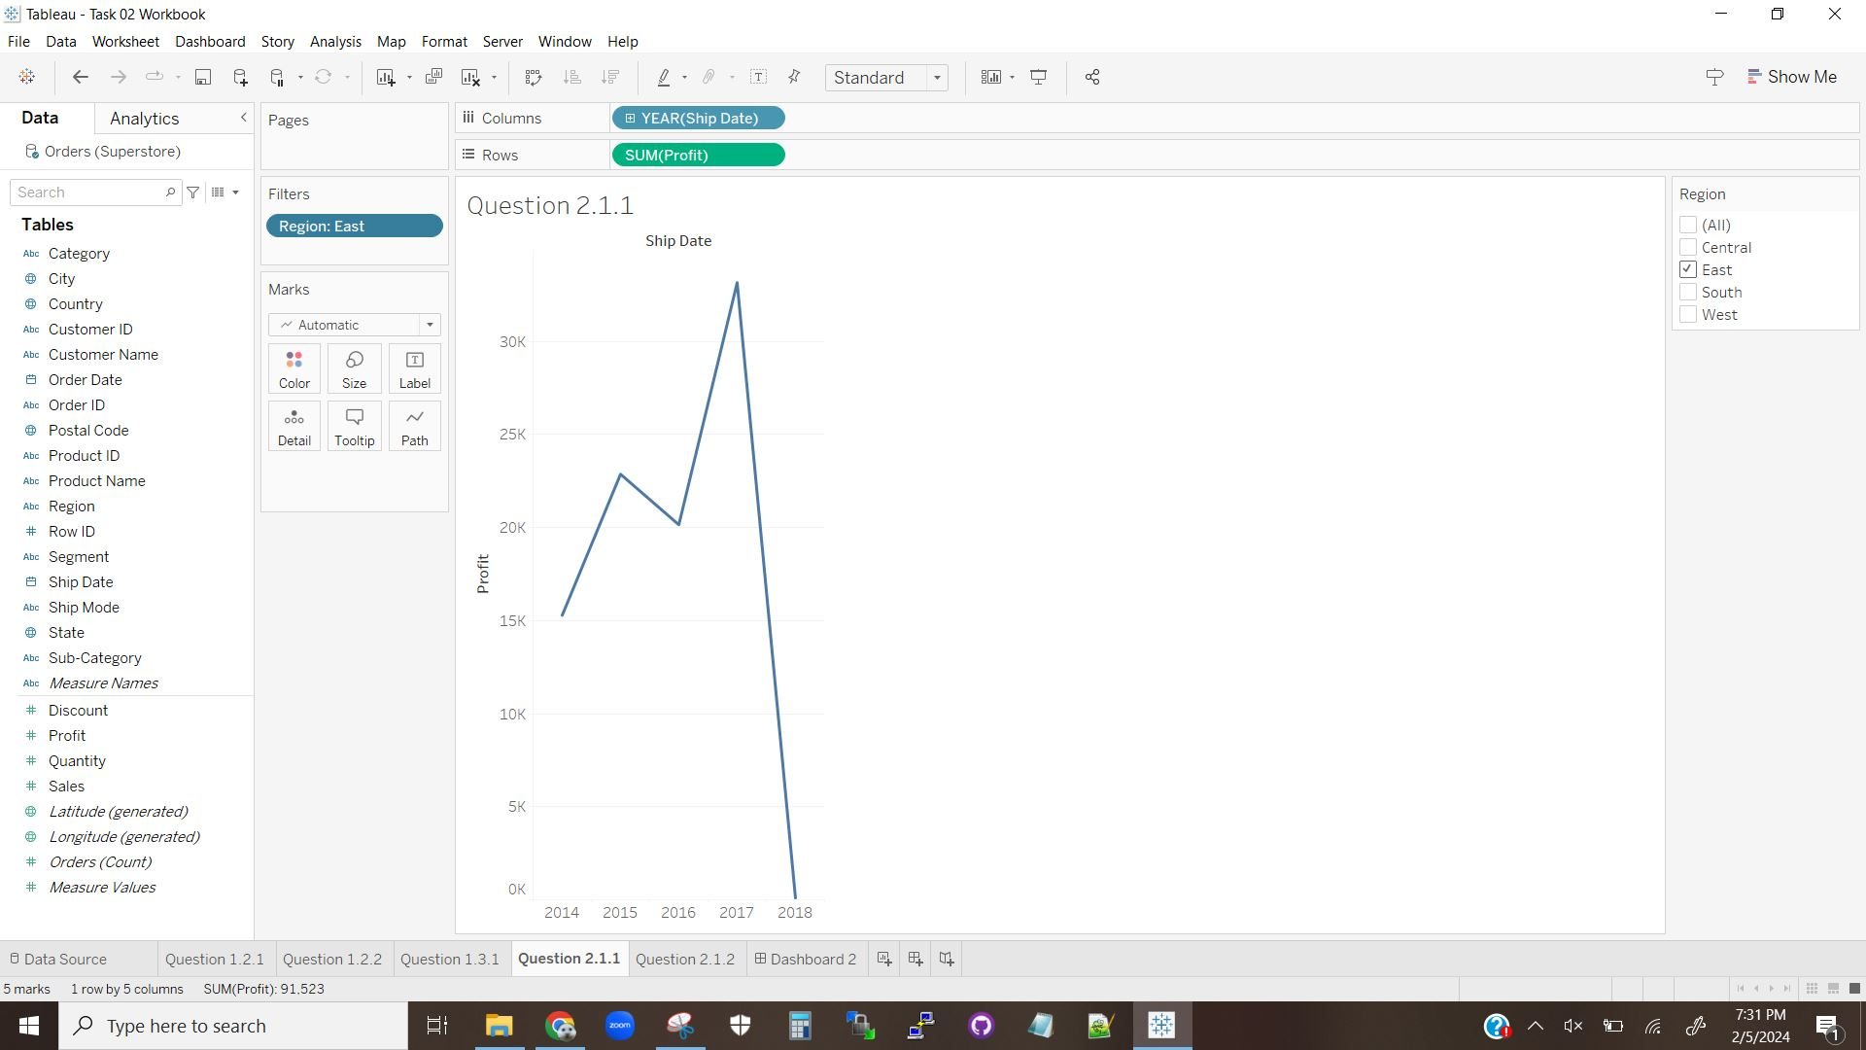

The above visualization is a line chart displaying the profits per year for the Eastern region.

## Question 2.2

**Visualization 2.2.1**

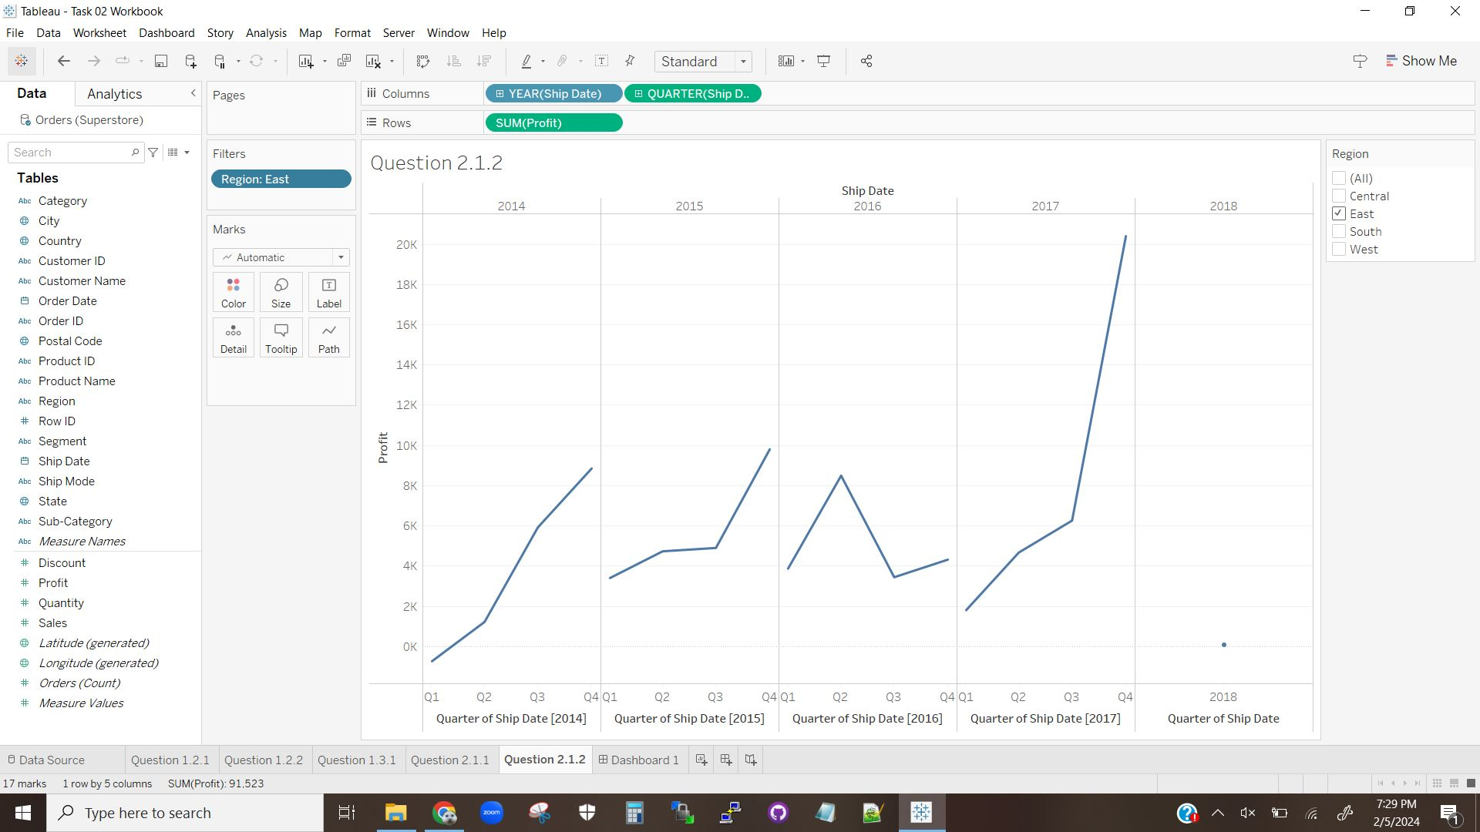

The above visualization is a breakdown of Visualization 2.1.1, where each year is now broken down into each of its quarters with a line graph displaying the changes in profit over time.

## Question 2.3

**Visualization 2.3.1**

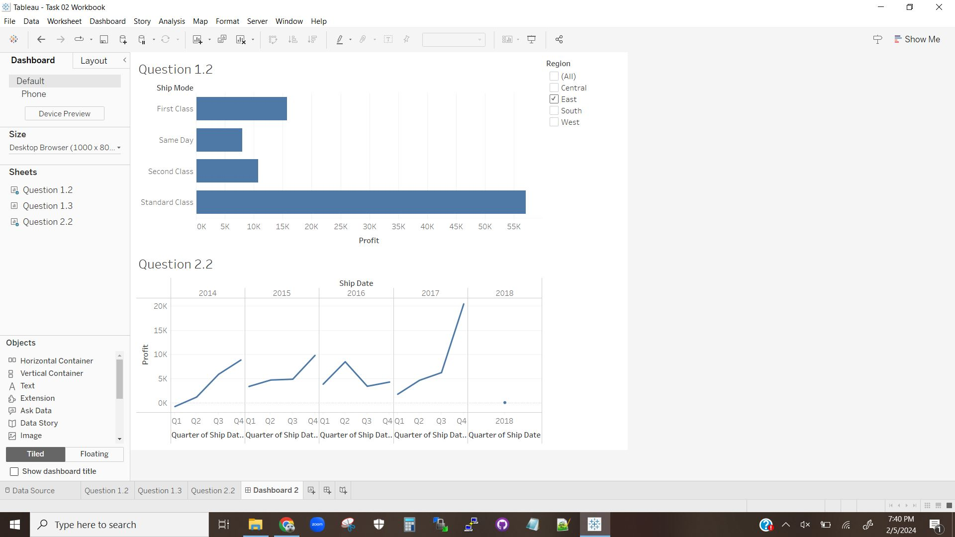

The above visualization displays a Desktop that links the worksheet from question 1 to the worksheet from question 2.

## Question 2.4

**Visualization 2.4.1**

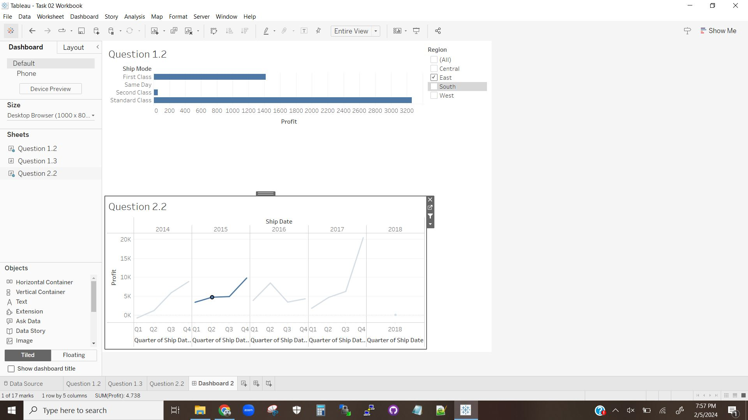

The above visualization shows how selecting Q2 for 2015 causes the bars in worksheet 1 to update to only the profits for that particular quarter.

Upon selecting a second quarter in the second worksheet, Tableau updates any linked worksheets, in this case worksheet 1. The bars in worksheet 1 are updated to reflect the profits in that region for that particular quarter only.

## Question 2.5

This task was designed to teach students how to link worksheets so that they share filters as well as use one worksheet as a filter for another. This demonstrates how Tableau can create layered, interactive visualizations to display complicated data in an understandable form that also allows for the user to easily change the portions of the data displayed without errors. Overall the interactivity is clean and well done, and once setup is very easy to use. Some of the methods necessary to link worksheets is not particularly obvious but is overall not terribly hard to find.

# Question 3

## Question 3.1 and Question 3.2

**Visualization 3.2.1**

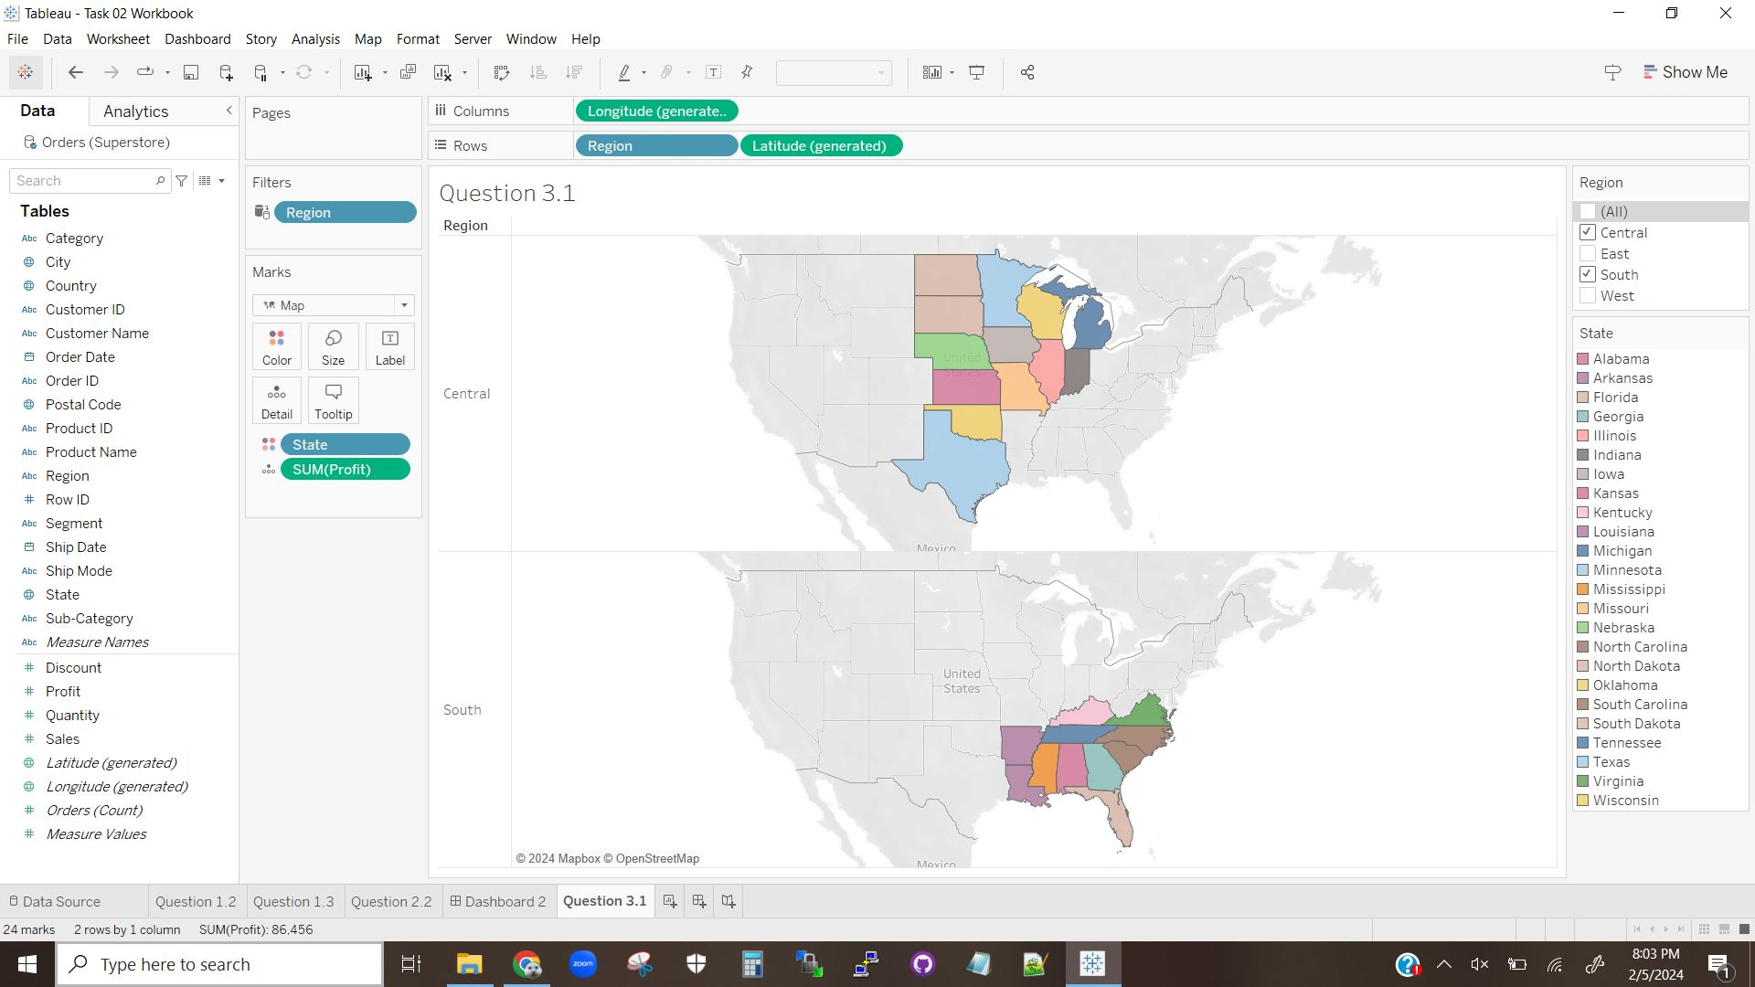

The above visualization displays two maps of the Central and Southern regions of the US, with each state being a different color. If the cursor is over any state, the profits for that state are displayed.

## Question 3.3

The profits of Oklahoma are $4,854.

The profits of Texas are $-25,729.

## Question 3.4

**Visualization 3.4.1**

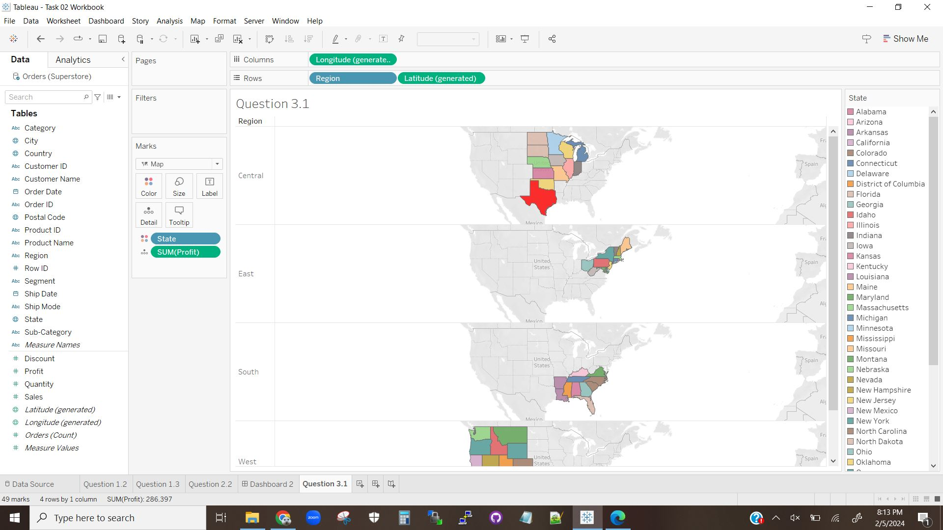

The above visualization shows what happens if the Region filter is removed.

Then all of the Regions are displayed.

## Question 3.5

**Visualization 3.5.1**

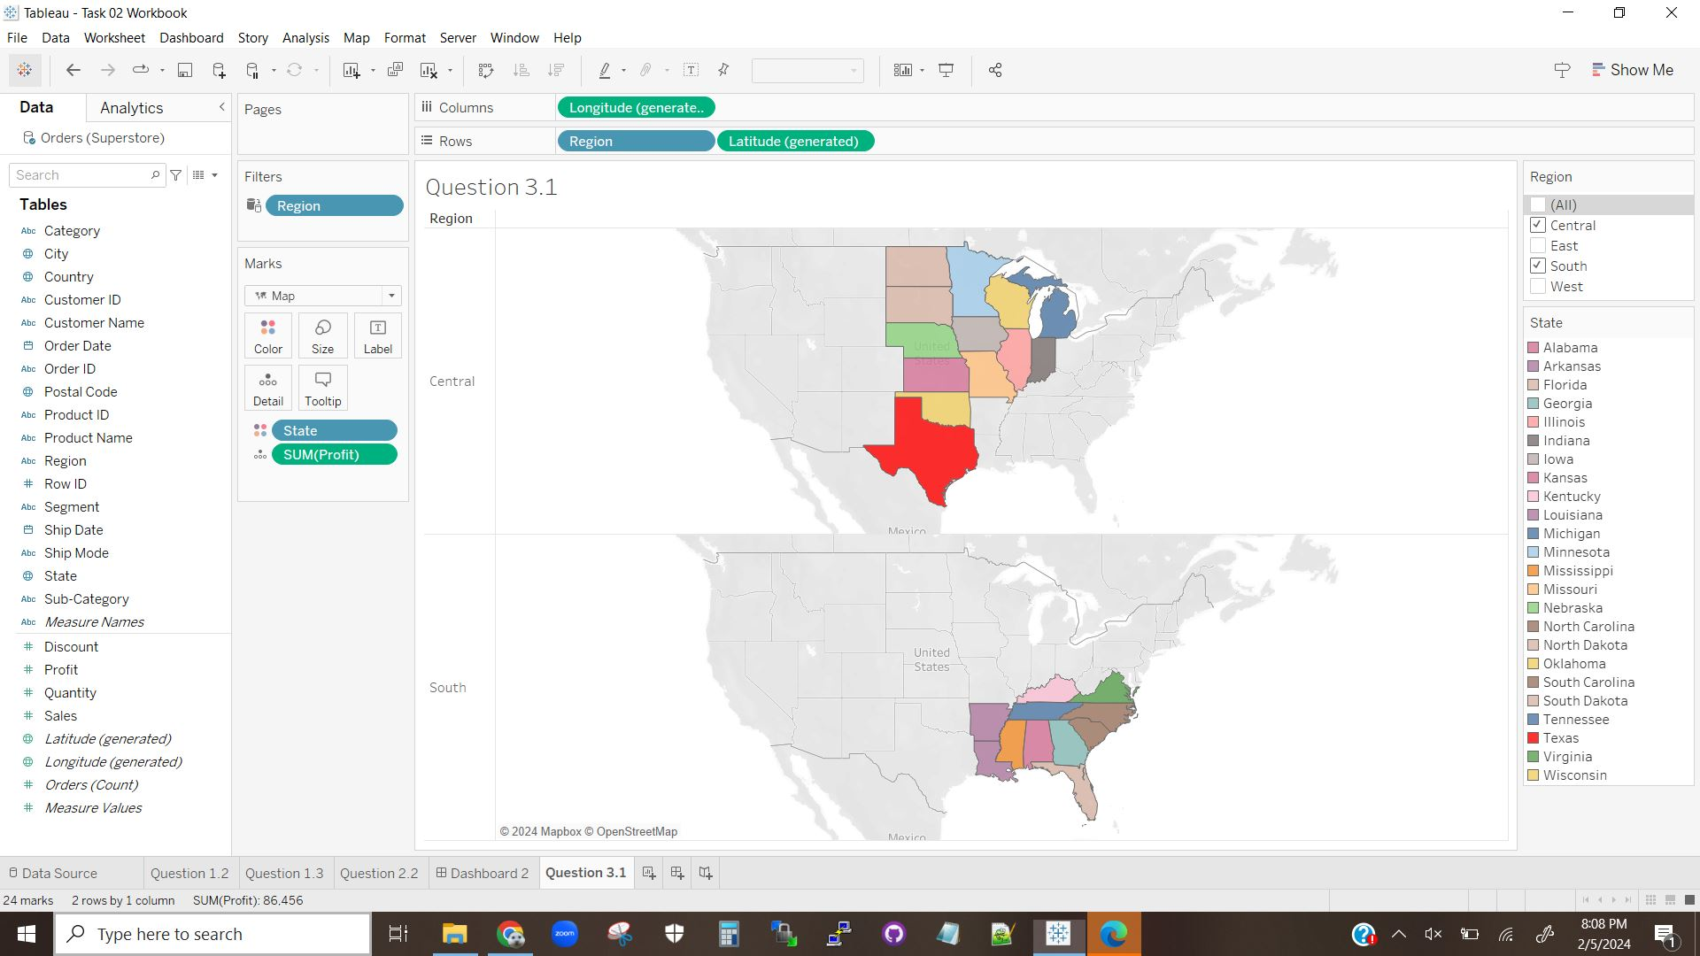

The above visualization shows the change from Visualization 3.2.1, showing the change in the color of Texas.

Yes, you can change the color of a specific state.

## Question 3 Explanation

The purpose of this question was to demonstrate how to generate visualization based around data that is a geographical map. The question also shows how a map visualization can contain useful information, as well as how to modify the map based on need or user preference.